

ITP & PDM FINAL PROJECT  
COVER LETTER

|  |  |  |  |
| --- | --- | --- | --- |
| Student Information | Surname:  Espinoza | Given Name:  Fabio | Student ID:  2440103161 |

Course Code: COMP6056 & COMP6502

Course Name: Program Design Methods and Introduction to Programming

Class: L1AC

Major: Computer Science

Title of Assignment: Naruto DJANGO

Name of Lecturer: Jude Joseph Lamug Martinez

Plagiarism/Cheating

Binus International seriously regards all forms of plagiarism, cheating and collusion as academic offenses which may result in severe penalties, including loss/drop of marks, course/class discontinuity and other possible penalties executed by the university. Please refer to the related course syllabus for further information.

Declaration of Originality

By signing this assignment, I understand, accept and consent to BiNus International terms and policy on plagiarism. Herewith I declare that the work contained in this assignment is my own work and has not been submitted for the use of assessment in another course or class, except where this has been notified and accepted in advance. Signature of Student: (Fabio Espinoza)

Program Description:

This is a web-based application that has many features. The theme of this website is based off the very popular anime “Naruto”. This website has user system, translation, twitter fetching, and music playback features. The framework used for this application is Django version 3.2.1. The Database Engine is SQLite3. The front end of this project was done with HTML, CSS, JavaScript and third-party libraries. These third-party libraries are bootstrap for styling, barba.js for transitions, and GSAP for animations.

**ERD & Class Diagram:**

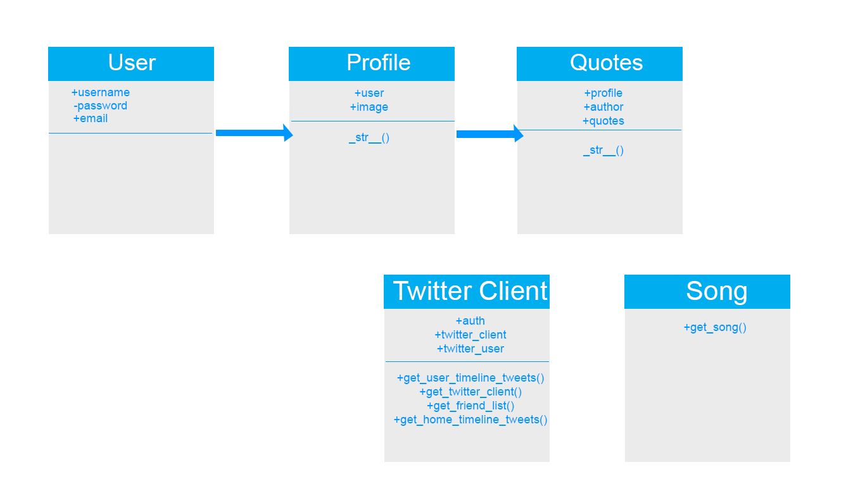

My ERD Diagram shows my classes and the relationship between them. The user class is generated by Django or should I say model which is what it is in Django terms. So, I didn’t overwrite any methods since there was no need to. My web app will handle setting and getting on the front end. Users can update their username, password, and email via the forms I give in the website. The properties of the User model are the username and password. I added in the email property in the forms file of my project. My Profile model has a one to one relationship with the User model and also adds a property of an image. Again there is no need for setters and getters because the user can do that in the front end with the use of my forms. Quotes model has a one to one relationship with my Profile model and I add the properties of author and quotes. I also add a to string method to the Profile and Quotes model for convenience. The Twitter Client class and Song class actually have no relationship to my models, but their functionality is used to display quotes and songs to my templates.

**Application Interface:**

Homepage (New User):

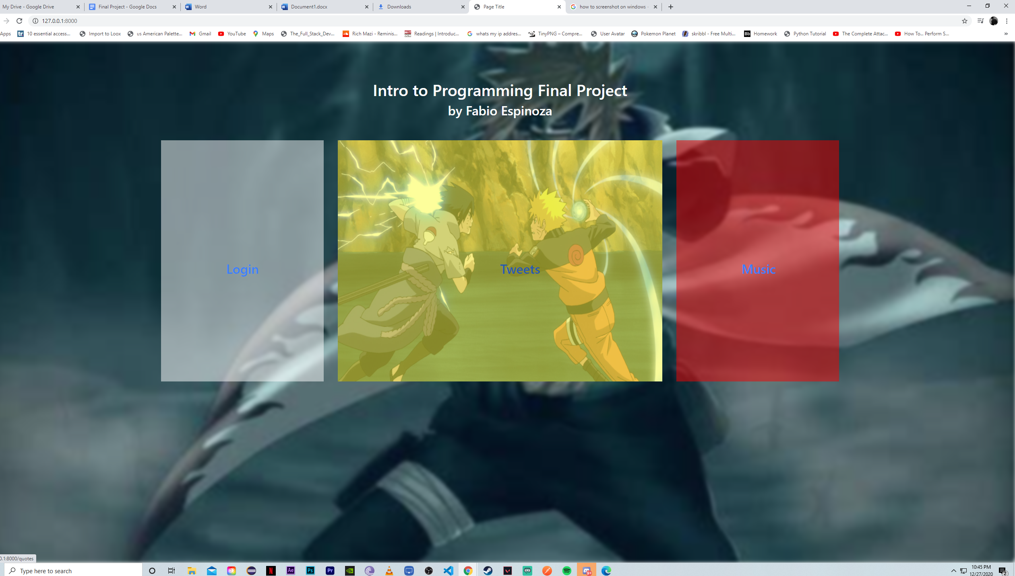

This is my homepage as a brand-new user. Also, when you hover over the div elements a picture appears for the Login, Tweets, and Music.

Login Page:

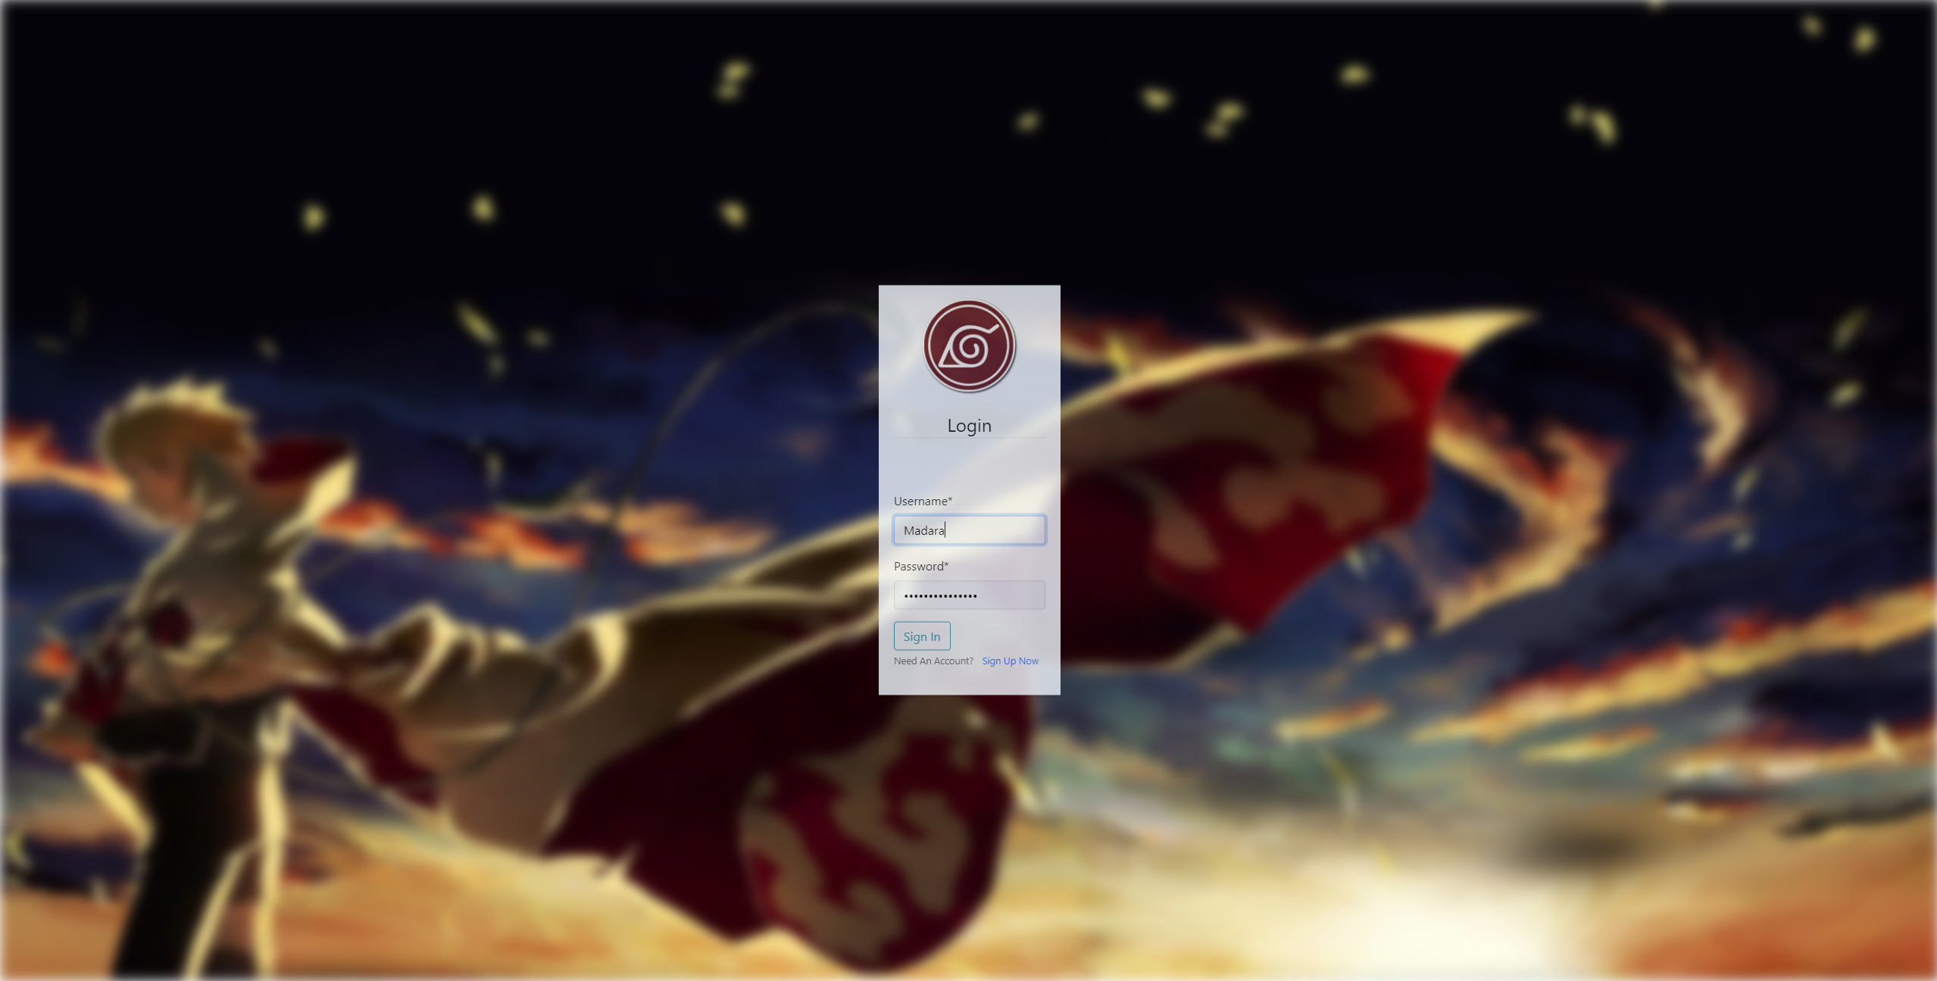

Registration Page: (New Users)

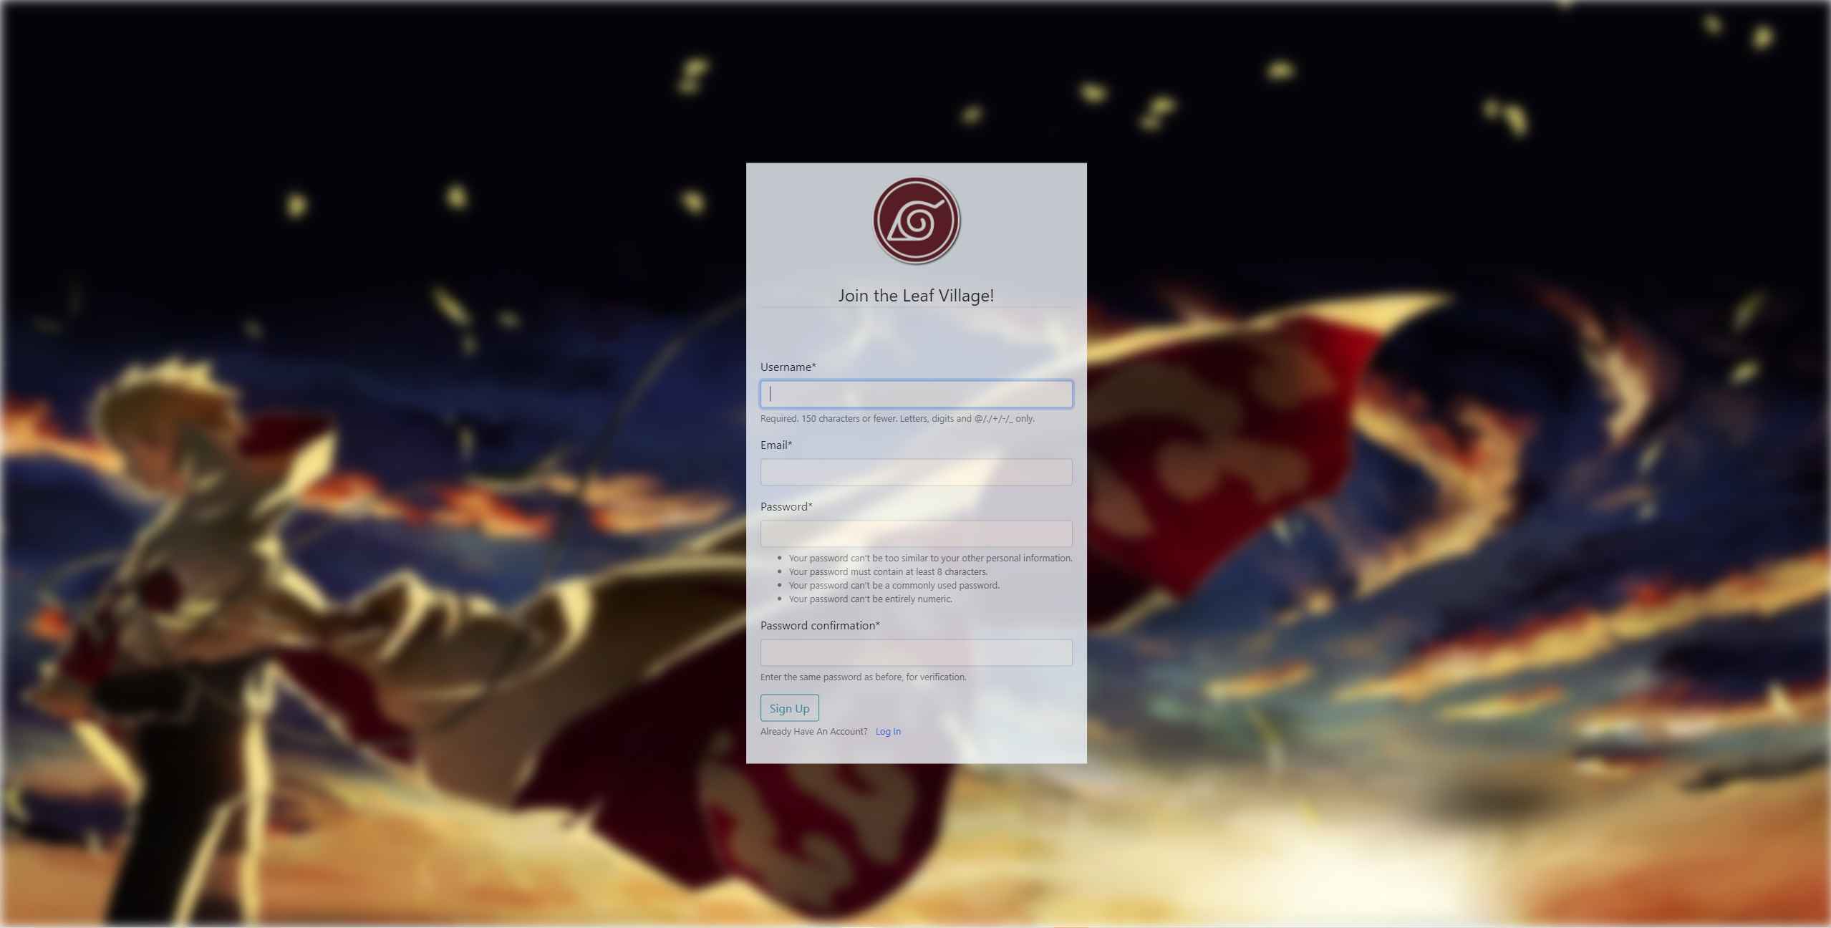

Homepage (Logged In):

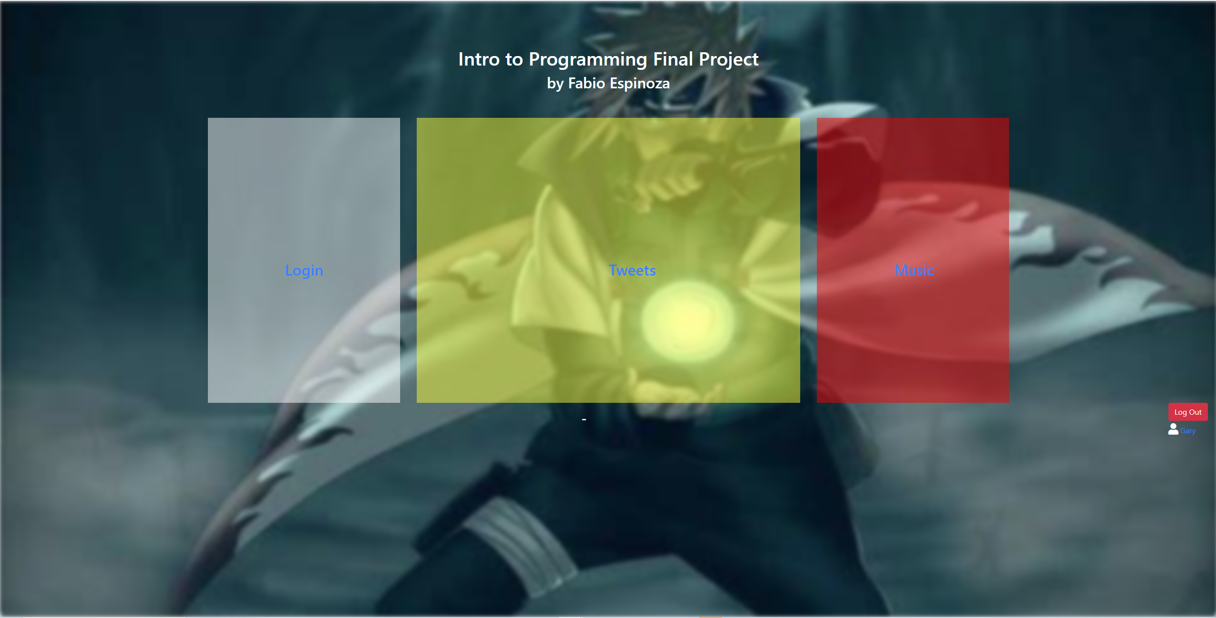

The difference is there is a profile and logout button on the bottom right of the template.

Profile Page:

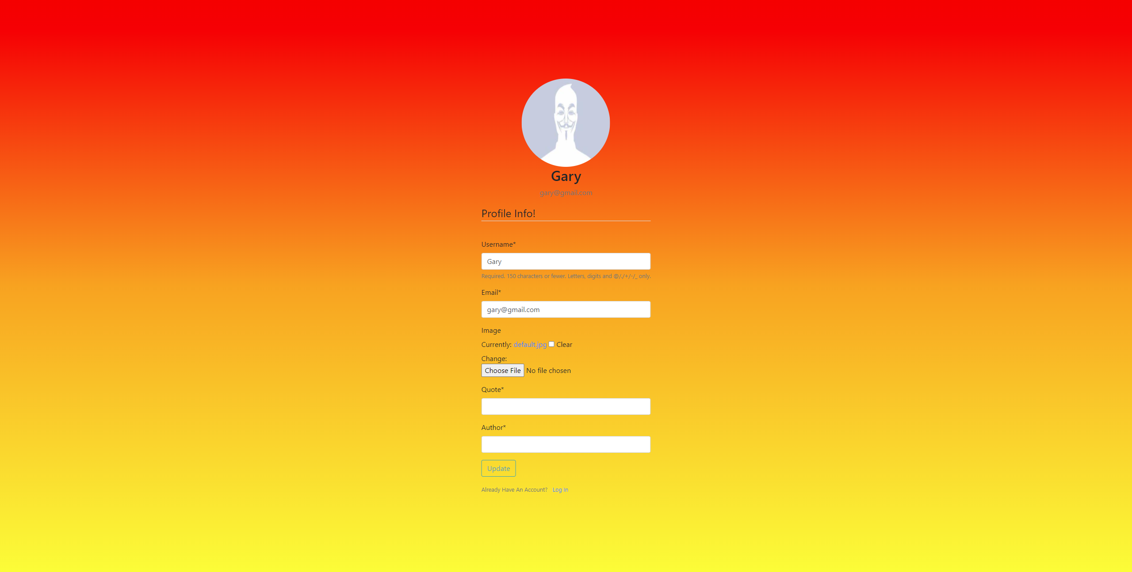

Profile Page Updated:

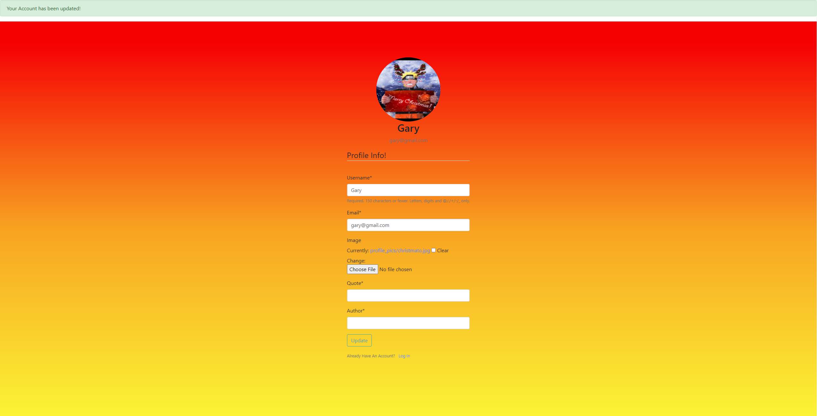

Quotes (From Twitter):

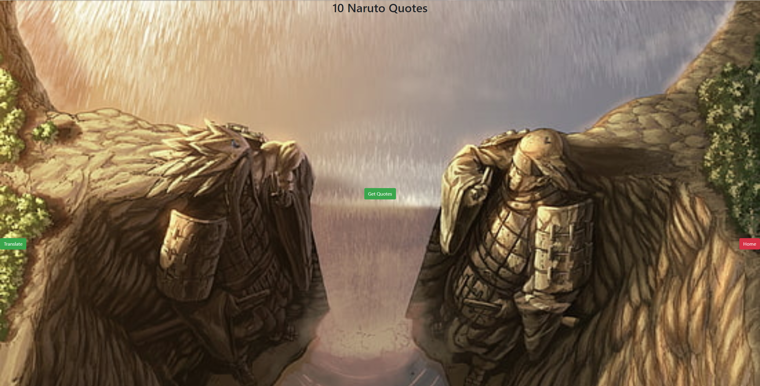

Quotes (Fetched Tweets/Quotes):

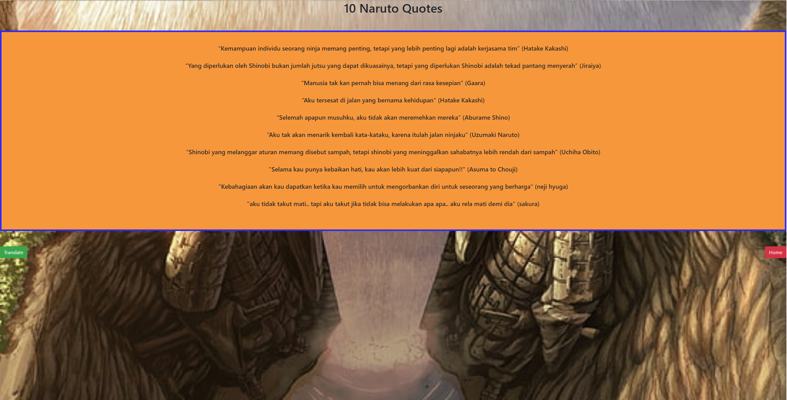

Quotes (Translated via Google Translate API):

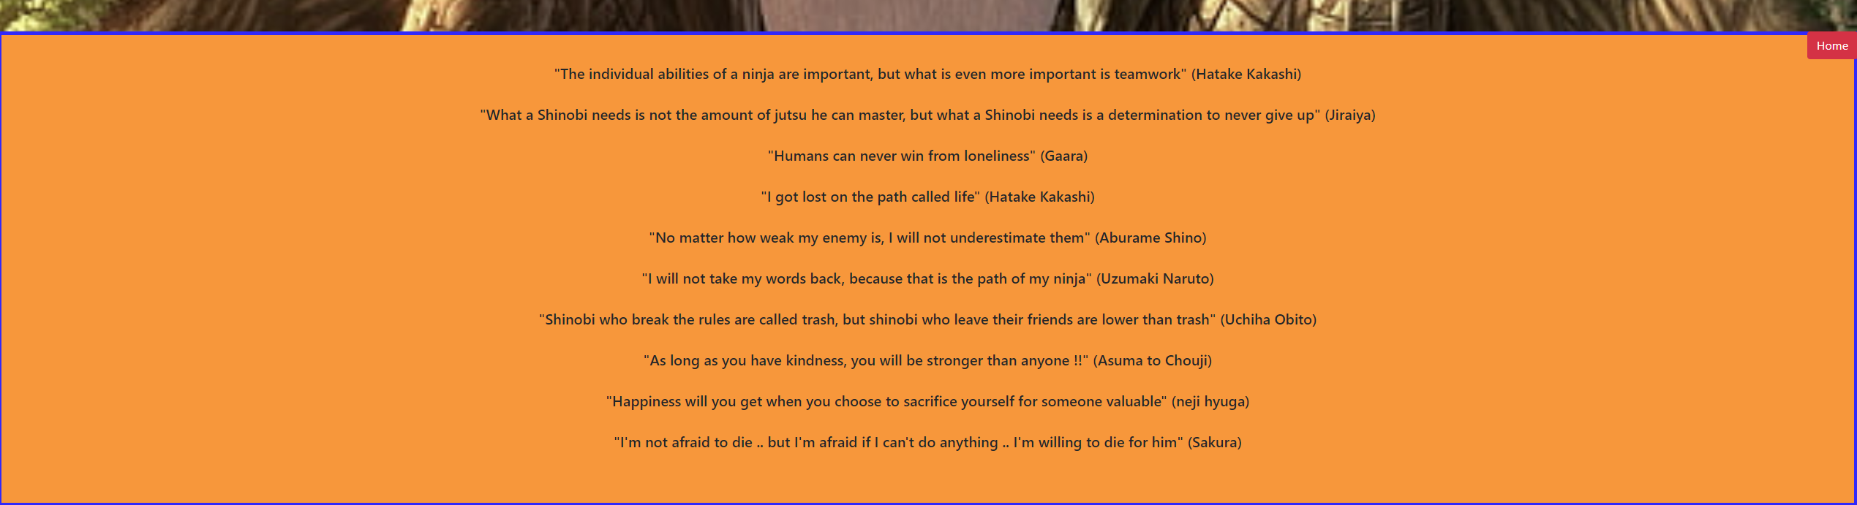

Music:



Logout:

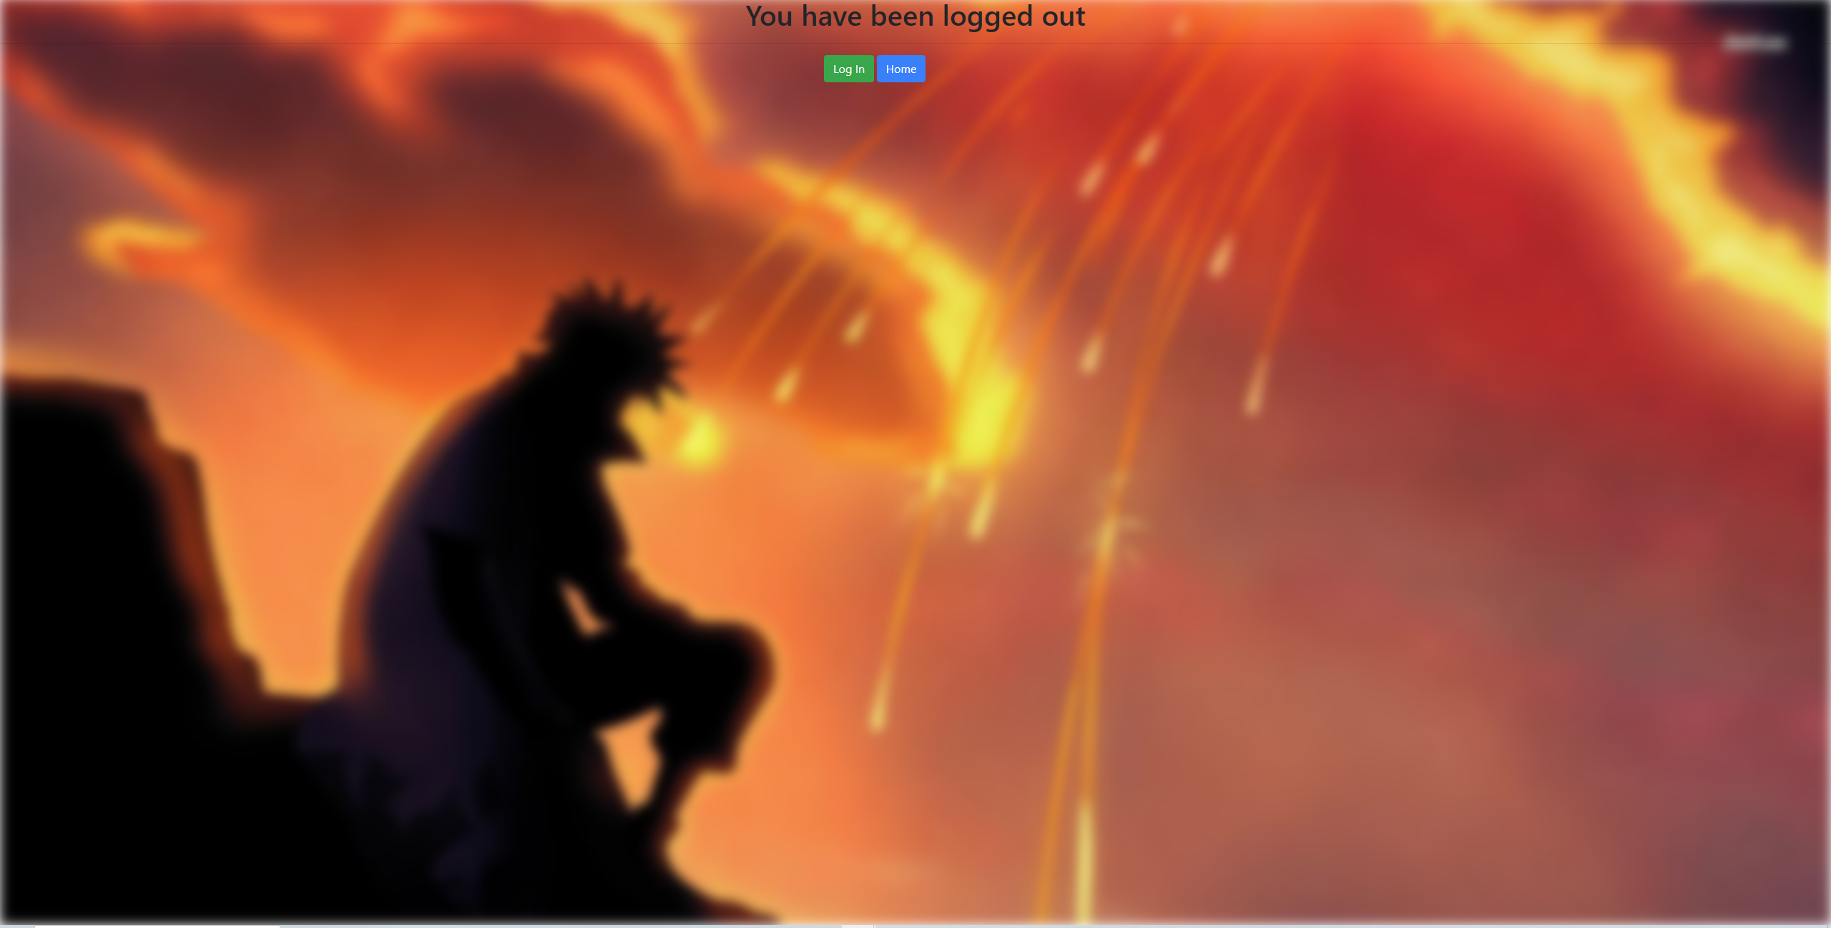

**Program Walkthrough:**

This website introduces you to a homepage that prompts the user with 3 options. Login, Quotes, Music. A brand-new user does not have to be logged in to access the Quotes and Music feature of my website. However, it is a good idea to start with creating an account to the website as it allows for more features.

The Log-In page of the website asks for the account credentials of the user and if a user does not have an account then he can make one as there is a hyper-link to the Registration Page. The Registration Page will ask the user for a username, email, password, and password confirmation. Once the account is made then the program will redirect the user to the homepage with a flash alert. This flash alert will be a one-time pop up and will inform the user he can now login.

Once Logged-In the user will once again be redirected to the homepage but there should be a slight addition to the homepage. There should be the user’s username above a Profile button on the bottom right of the homepage. This will appear every time a user is logged in. This button under the user’s username directs the user to the Profile page. The Profile Page is where the user can view his Username, Email, and Profile Picture. This Profile Picture is defaulted to a generic picture. The user can also update these credentials if he pleases. In addition to the mentioned properties the user can also add in a favorite quote by his favorite author. These quotes can be found by the Quotes feature of the website.

The Quotes feature of the website shows 10 Naruto Quotes said by the characters of Naruto. They are originally in Bahasa, so I added a translated feature that displays the quotes again in English. Here the user can copy and paste the quote into his Profile Page. Once this is done the quote will now display in his homepage for them to see every time, they login.

Finally, the Music feature of my website has the ability to play a sample of my chosen anime openings that I handpicked. This feature was a bit random and didn’t relate to the website other than the anime portion of the music. However, since this project was a learning experiment for me, I decided to include it and it couldn’t hurt the website in anyway. Just a fun feature, I guess.

**Libraries:**

GSAP – this is a JavaScript library that is used for animations throughout my forms. It is very fluid and modifiable compared to what CSS and Vanilla JavaScript allows you to do.

Bootstrap - this is one of the most popular front-end frameworks for CSS and it allows you style your page in a modern manner without much CSS needed.

Pillow - this is a third-party Django library that is used to handle images within your application. This can be installed by the python library manager (PIP).

Spotipy - Spotipy is a lightweight Python library for the Spotify Web API. This will give you all the functionality the Spotify API offers such as music playback, artist information, and song information.

Tweepy - This is a python library used to access the Twitter Web API. This will allow many functionalities such as finding users, finding tweets, filtering tweets, and much more.

**Lessons Learned:**

The lessons I learned from this project mostly came from the database aspect. I learned how to run queries to make sure my models were working correctly and updating correctly. Along with the database I learned how to create Django conventional models that connect to one another and save into my database correctly. Along with models I learned how to manage migrations and delete ones that may interfere with my models. Relationship between tables is a concept I learned. OOP (Object Oriented Programming) is something that has been refined with me doing my project. Also learning the conventions of Django and how the framework is used has been a fun process to learn.

**Code Explained:**

[**https://docs.google.com/presentation/d/1n4Omixh8W8qaZTLTr-059Qn1rAZz-zEFXjJz7JIgX80/edit?usp=sharing**](https://docs.google.com/presentation/d/1n4Omixh8W8qaZTLTr-059Qn1rAZz-zEFXjJz7JIgX80/edit?usp=sharing) **-** Google Slides Link to my Code Explanation.

**Project Link:**

https://github.com/FabioSebs/FinalProject

**Project References:**

<https://docs.djangoproject.com/en/3.1/>

<http://docs.tweepy.org/en/latest/>

<https://spotipy.readthedocs.io/en/2.16.1/>

<https://greensock.com/docs/>

<https://pillow.readthedocs.io/en/stable/>